Series: Rev’d Up
Sermon: The Challenges of Church
Main Scripture: Revelation 2:1-11 (NASB)
Supporting Scripture: Isaiah 44:6
Pastor Kip McCormick
Date: June 9, 2024

Message Takeaway: If you remember the greatest thing, you’ll be able to survive anything.

Supporting Thoughts:
- Each of Jesus’ messages to the seven churches has three similarities, three differences:
  - 3 Similarities: 1) Addresses the leader of the church and Christ as the one speaking; 2) there’s important content in each message; 3) Each has a call to action by Christ.
  - 3 Differences: 1) All the letters reveal strengths and “’attaboys” except one: Laodecia 2) Each has a rebuke except two – Smyrna and Philadelphia; 3) all the churches are different, yet we can make applications to our churches today.
- Angel: “the angel of the church” = pastor, elder of that church.
- Christ walks among the churches and is active. He did it then. He does it now.
- First Love: The greatest thing: Loving God with our hearts, souls, minds, and strength; Loving others as we want to be loved.
- Truth and works without love lead to legalism and spiritual abuse. Love without truth leads to confusion and an inability to discern truth from lies.
- Ephesus was off track. The remedy to get back on track: Remember, repent, and do.
- Nicolaitans: Group of false teachers active in Ephesus and Pergamum (Rev 2:15) who encouraged self-indulgence, sexual immorality and the eating of meat sacrificed during pagan temple worship. (They would combine pagan temple worship with worship of God.)
- Nicolaitans: Greek: nikao = one who conquers and laos = people.
- Nicolaitans Hebrew: “nokhal” is a verb meaning, “we will eat.” So what? Jesus:
“To him who overcomes the ones who conquer people (Nicolaitans)/the ones who satisfy their appetites sexually/immorally (Nicolaitans), I’m going to reward you with real food: You get to eat from the tree of life.”
- We overcome by knowing and applying God’s word in our lives; sharing Jesus with others in truth and love, and serving others with love.
- Smyrna: God gives strength to those who suffer and rewards those who endure.
- Great persecution by two forces: 1) Roman Government 2) Jewish synagogue rejection for worshiping Jesus as Son of God.
- Poor: Jesus here isn’t talking about money in the bank. He’s talking about Christ in your heart.
- Blasphemy means to be the target of hate and slander – here by a specific group of people.

- Your suffering has an expiration date. The presence of trials doesn’t negate the presence of God.
- Two questions to ask God when going through suffering: 1) What are You trying to teach me? 2) How can I respond in a Christ-like manner?
- Second death is the final destiny of the unsaved after they are judged and cast into the lake of fire in their resurrected bodies (Rev 20:14; 21:8).
- Overcomers: Will be raised in our immortal bodies to experience eternal life in glory.
- Challenge: Memorize Psalm 56:3-4 When I am afraid, I will trust in You. In God – whose word I praise – In God I trust; I will not be afraid. What can mortal man do to me?” (NIV 1984)
Discussion Questions:
- What was the thing that challenged you the most in today’s teaching? Why?
- What did the Ephesian Church do well? Where did they misstep? What’s the warning for us?
- Talk with your group about suffering. What can we learn from the Smyrna Church about suffering and how to deal with it well?
- Why do you think Jesus wanted to address these two churches first?
- If Jesus were to show up at New Life Fellowship, how would He address us? Where can we build our strengths and in what areas can we improve?

Seven Churches of Revelation

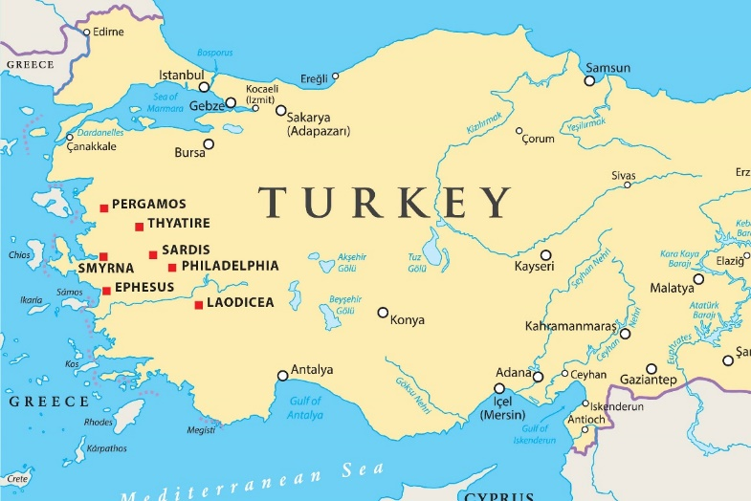

Sources: Voddie Baucham (Voddie Baucham Ministries); Eliyahu Lizorkin-Eyzenberg, Israel Bible Center (multiple books and commentaries); Michael Heiser (Naked Bible Podcast; multiple books); David Jeremiah (Shadow Mountain Community Church; multiple books); John MacArthur (multiple books, sermons, study bible; Grace to You Ministries); Chuck Missler (multiple YouTube videos on his Revelation Commentary); Grant R. Osborne (Revelation Exegetical Commentary); RC Sproul (multiple sermons and writings), Chuck Swindoll (New Testament Commentary – Revelation, as well as Insight for Living Broadcast, 2 series on Revelation) Warren Wiersbe (New Testament Commentary); The Bible Project (multiple videos); Through the Word Bible App.

